Alvadore Neighborhood News







March 2018

**Alvadore**.. The lines to the left outline my version of Alvadore. (this document is not limited to those areas) I see us as a community of rural properties surrounding the unincorporated community of Alvadore. This publication is intended to bring communication from neighbor to neighbor. We are a community of movers and shakers and often plan community gatherings, support community events and generally enjoy life in the country. (Community Breakfasts’, BBQ’s, Carnivals, Food For Lane County Pantry events and our Community Library just to name a few) The intent is to share information on a quarterly basis. We need your input to accomplish the goal.

**Cheryl Chambers**

**541-689-4621**

**Cheryl@TheHomeForUs.com**

PS. The mailing list for this document was based on the outlined area, and includes those outside the area upon request.

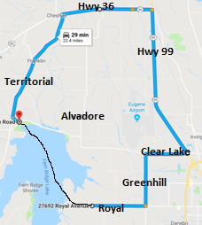

|  |  |  |
| --- | --- | --- |
| **Day by Day** | | |
| **March 11** | **Time** | **Time Change** |
| **March 17** | **6:30pm** | **Alvadore Bingo** |
| **March 17-18** |  | **Daffodil Drive & Fest** |
| **March 22** | **7:00pm** | **Potluck Fire Station** |
| **April 1** |  | **Easter** |
| **April 21** | **6:30pm** | **Alvadore Bingo** |
| **April 26** | **7:00pm** | **Potluck Fire Station** |
| **May 19** | **6:30pm** | **Alvadore Bingo** |
| **May 24** | **7:00pm** | **Potluck Fire Station** |
| **August 18** |  | **Fern Ridge Golf** |

**ALVADORE COMMUNITY LIBRARY**

**90829 Alvadore Rd, Alvadore 97448**

If you’ve never visited the Alvadore Community Library, please stop by! There are books, movies, WiFi and library cards are free. To make books available when the library isn’t open, we will soon install our “Little Free Library,” (a cute little house) in the parking lot, where you can pick up a book, or leave a book. We’re looking forward to our annual Summer Reading Program, which includes reading, treasure hunts, puzzles, and more. If you‘re interested in volunteering at the library or help with the reading program - or if you’d like to be advised of dates and times for the reading program, please e-mail

[alvadorelions@yahoo.com](mailto:alvadorelions@yahoo.com)

**Everyone is invited to the potluck on the fourth Thursday at the fire station**

**Sponsored by the Alvadore Lions Club**

|  |  |  |
| --- | --- | --- |
| **Hour by Hour** | | |
| **Sundays** | **Alvadore Church** | **10am** |
| **Mon-Sat** | **Alvadore Store** | **7am-9pm** |
| **Sundays** | **Alvadore Store** | **8am-9pm** |
| **Daily** | **Fern Ridge Store** | **7am-10pm** |
| **Monday** | **Alvadore Library** | **4pm-9pm** |
| **Tuesday** | **Alvadore Library** | **4pm -8pm** |
| **Wednesday** | **Alvadore Library** | **10am-6pm** |
| **Saturday** | **Alvadore Library** | **10am-Noon** |





**LIBRARY HOURS**

**Mon 4-6**

**Tue 4-8**

**Wed 10-6**

**Sat 10-12**

Non Profit – Run by Community Volunteers

Alvadore Oregon, Wikipedia:

Alvadore is an unincorporated community in Lane County, Oregon. Located nine miles northwest of downtown Eugene and one mile Northeast of Fern Ridge

Alvadore was named for Alvadore Welch of Portland, who built the Portland, Eugene and Eastern Railway through the community. The railway was later acquired by the Southern Pacific Railroad, but in 1936 the track was torn up. Alvadore Post office was established in 1914.

ALVADORE LIONS CLUB – you can be a member.

Q1 2018 ● Volume 1, Issue 1 ● March 2018 ● Editor Cheryl Chambers (541) 689-4621

The Alvadore Lions Club, a part of Lions International, is a group of volunteers who do good works in our community, like sponsoring the Alvadore Community Library, facilitating the Alvadore Wish Tree and Shoeboxes for Seniors programs, working with the Oregon Lions Sight and Hearing Foundation to help people obtain glasses or hearing aids – and more. Funds for these projects are raised through pancake breakfasts, annual garage sale, holiday bazaar, book sales, bake sales, and chicken barbecues. These events provide opportunities to meet your neighbors and help your community! We meet twice a month, on the second and fourth Thursdays at 7:00 p.m. at the Alvadore Fire Station. The second meeting is a community potluck which our Alvadore neighbors are encouraged to attend. In addition, at the potluck you can learn more about Lions and how you can help. -- Donna Korn

questions, please email [alvadorelions@yahoo.com](mailto:alvadorelions@yahoo.com)

**90829 Alvadore Rd,**

**Alvadore, OR**



**Missing information? Something not quite correct? I'm relying on neighbor input to improve.**

ALVADORE HALOWEEN CARNIVAL HISTORY by Kim King

Shortly after the 2015 carnival, based on community support and continued growth, the committee decided the carnival is an important community event and elected to move to an incorporated nonprofit corporation.  After several months of research and planning, we formed our Board of Directors and registered with the State of Oregon as a nonprofit corporation, then registered with the IRS to obtain an EIN so we could open a bank account.  We are now in the process of filing with the IRS for our nonprofit, charitable status.  This has been a tedious process that has taken much longer than we anticipated but the board is committed to moving forward.

For the future successes of the carnival, there needs to be continued support from the community in the form of donating and volunteering.  There are so many ways community members can assist to ensure this event is not just part of our history but also part of our future.  If you or someone you know is interested in giving a little volunteer time between now and the carnival, please contact me at kim_equine@comcast.net

We have plenty of things you can help with in the weeks and days before the carnival as well as the day and night of the carnival.  Just a little of your time can go a long way.

I want to share with you a bit of history of the Alvadore Halloween Carnival.  In the early 1970’s, a group of Alvadore parents decided to host a party for some of the kids of the Alvadore area for Halloween in lieu of walking/driving kids around Alvadore to trick or treat.  The first year was in a family’s home, the next year parents decided is should be something that all kids in the area could attend because trick or treating was getting more dangerous plus there were no sidewalks or street lights so they hosted a party/carnival in the old Alvadore Christian church (which was located on the corner of 8th and B Street) and then it moved to the new Alvadore Fire Station where the event has continued to be held.  As the event grew, so did the volunteers.  The fire department and auxiliary members helped and eventually took on a major role in hosting the carnival, even assembling an elaborate and very popular haunted house.  Always in need of volunteers, the Alvadore/Franklin Lions group joined in.  Over the years, the Lions group assumed the carnival and operated it until 1998 when their group felt they could no longer provide a carnival that met the needs of the community.  I was asked to consider taking over managing it and they would continue to assist and provide support and some volunteers.  A few years ago, the carnival separated from the Lions and became its own community entity.



Neighborhood Real Estate Update



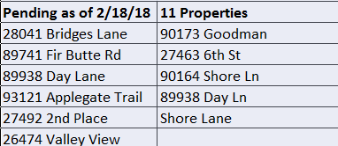

**Above are Sales that will be closing soon**

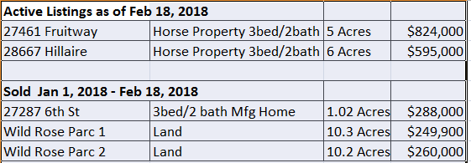

Cheryl Chambers

Realtor

541-689-4621

Cheryl@TheHomeForUs.com

Hybrid Real Estate

2445 Oakmont Way

Eugene, OR 97401

**Remember to Annually Clean your Flue**

If you use a fireplace, wood stove, or pellet stove, it is important to inspect and clean your flue every year. The most frequent fire-call we get during the winter months is for flue fires. Flue fires are dangerous because they can directly lead to a house fire. The amount of heat alone can ignite surrounding wooden supports. The smallest of gaps in seams and in mortar can allow hot gases to escape into attics and onto flammable material. So, the inconvenience and minor annoyance of cleaning your flue (or having it professionally cleaned) is far less than the impact of a house fire.

**Smoke Detectors**

**by Lt. Tressa Miller, Fire Prevention Coordinator**

Beep . . . Beep . . . Beep. When was the last time you heard that sound coming from your smoke detectors? We hope it was in the last thirty days . . . you know, when you last checked your smoke alarm! Do you need help? We can check your smoke alarm. Don't have enough alarms and can't afford them? We can also help. Give us a call at (541) 935-2226 and we will come out and assist you.

.

Messages from Lane Fire Authority



Here’s what’s happening in the neighborhood.

Want to learn how much your home is worth in today’s market?

Contact Cheryl for a no cost market analysis.

541-689-4621 or Cheryl@thehomeforus.com

**2018 Daffodil Drive & Festival**

**March 17-18, 2018 10am-4pm**

**Sponsored by and held at the Long Tom Grange**

**25855 Ferguson Rd, Junction City**

**Saturday and Sunday**

**Free Fun Had By All**

**Cans for Camp!**

**The Alvadore Christian Church Youth group is collecting recyclable bottles and cans. Call if you would like someone to pick them up for you.**

**541-689-4621**



**Easter - A New Day Dawns**

Service - 10:00 a.m.

Why does Easter Matter? So, Jesus came back from the dead, good for him. What does that have to do with me? You might be surprised at the answer the Bible gives. According to the grand sweeping story the Bible tells, Jesus’ resurrection is when God brings His future into the present. It’s a little taste, a preview of where our world is headed - resurrection! New life! A new world! A new you! A new….everything!

On behalf of our church family, I’d love to invite you to join us **Sunday, April 1st at 10:00 a.m.** as we celebrate Easter together. We’re celebrating the beginning of a new day, a new world, and maybe even, a new you.  **Marcus Omdahl**

27373 8th St, Junction City (Alvadore)

www.alvadorechristian.com

(541) 688-8884

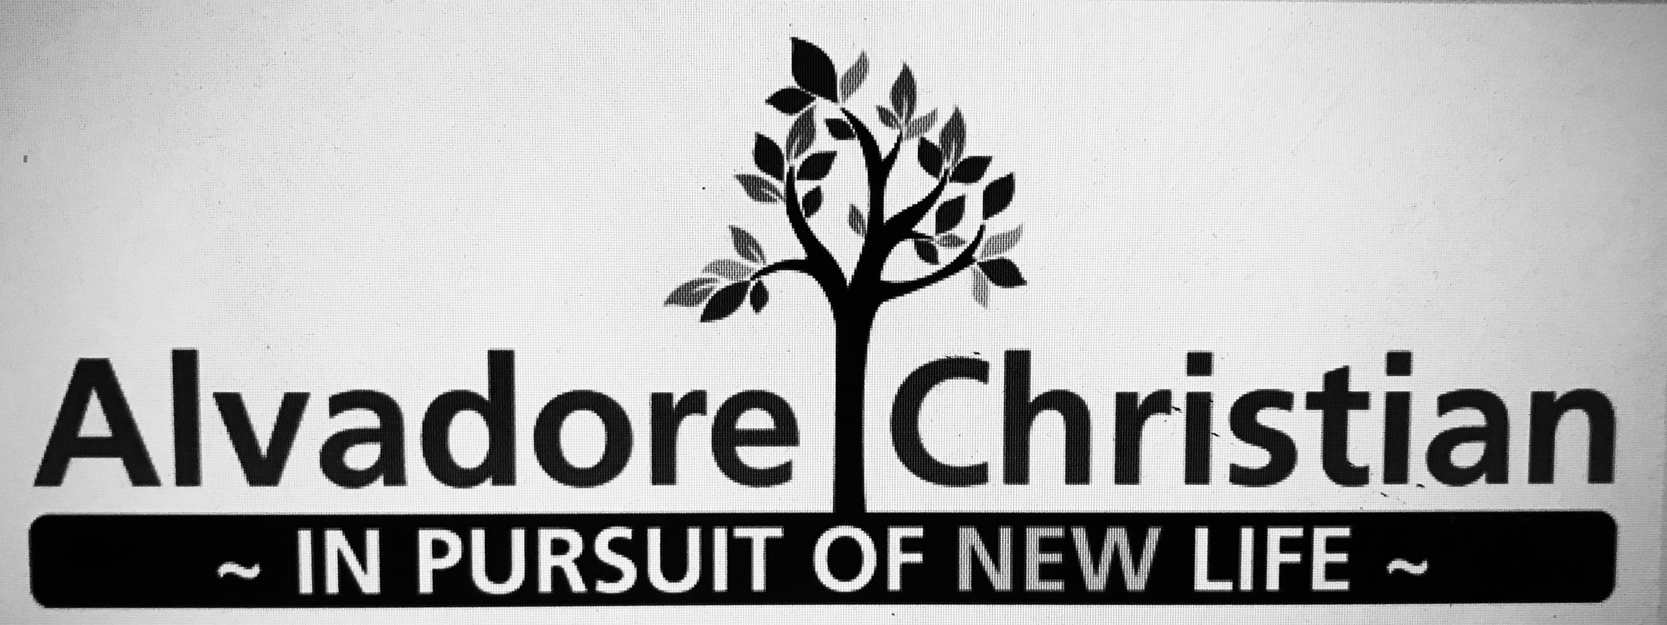

**Easter Egg Hunt!**

**After service 11:30ish**

**Hope you can make it**

Q1 2018 ● Volume 1, Issue 1 ● March 2018 ● Editor Cheryl Chambers (541) 689-4621

Page 2

**Fern Ridge Golf Classic**

**8th Annual**

**August 18, 2018**

**ANYONE IS WELCOME TO PLAY**

Alvadore Community Chest runs this event to help local rural families and individuals facing emergency financial difficulties, awarding funds toward their basic needs including, but not limited to: food, clothing, utilities, rent or mortgage payments

EIN#26-1985284

For tournament information contact Jim Keagy 541-915-8437 or Tom Davis 541-554-2746

**NEIGHBORHOOD WATCH**

Our neighborhood watch group currently does not conduct regular meetings. We communicate via email. If you would like to join this group contact

Kim King at 541-729-9846 or kim_equine@comcast.net

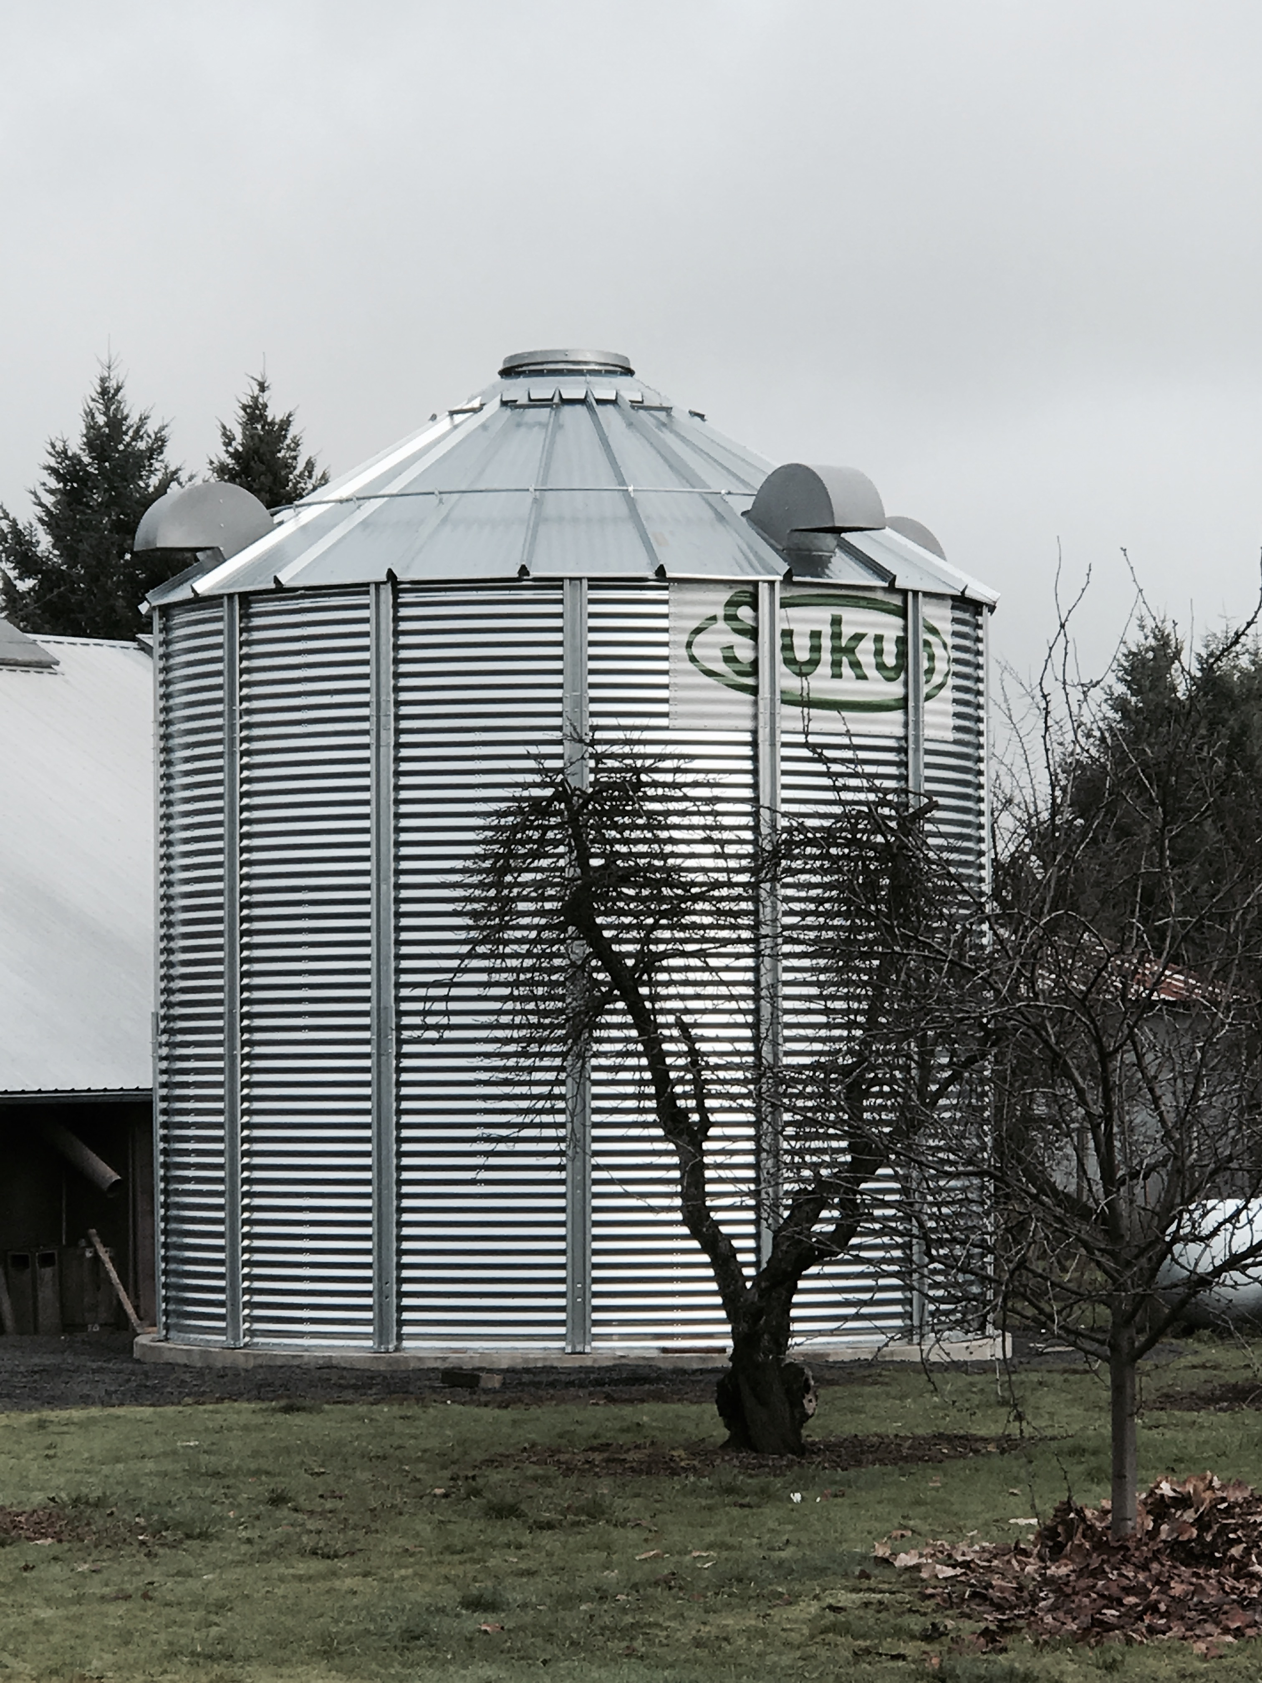

The Alvadore Dryer was purchased by the Bouer family in 1928. Grandfather Richard , Father Bill (William) and Son Willy (William)

You can’t miss the new structure on Alvadore Rd. This year the drying capabilities will nearly double with the new dryer pictured above. The focus of this operation is Filberts, aka Hazelnuts.

**Alvadore Dryer**

The cross roads of Railroad, Alvadore, and 8th Street

Q1 2018 ● Volume 1, Issue 1 ● March 2018 ● Editor Cheryl Chambers (541) 689-4621

Page 2

**Alvadore Post Office**

90828 Railroad St.

Alvadore, Oregon 97409

Hours: M-F 8a-Noon

Sat 9a-10:30a

We are looking for support for this publication along with feedback.

E-Mail: Cheryl@[TheHomeForUs.com](mailto:someone@example.com)

**SevaDog Pet Rescue**

Located on Alvadore Rd

Quality Family Rescue

Expert Match Making

Life Immersion Training

Non Profit

www.sevadog.org